Chapter 19, Problem 27.

Find the y parameters for the circuit in Fig.19.86.

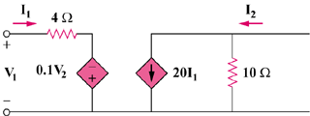

Figure 19.86
For Prob. 19.27.

